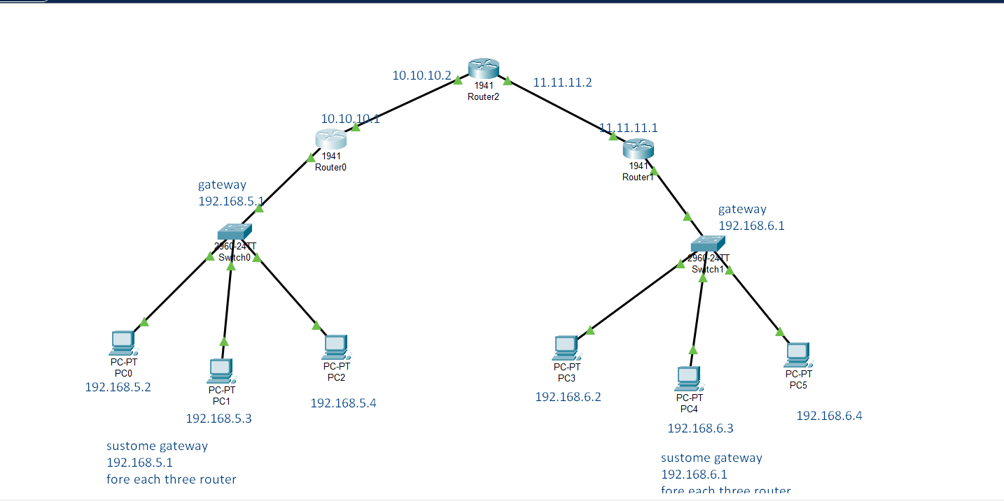

**Ip address Assiging and Configuring Router**

1st Router

1. no
2. Enable
3. Configure terminal
4. Interface gigabitEthernet 0/0
5. Ip address 192.168.5.1 255.255.255.0
6. No shutdown
7. Exit
8. --------------
9. Interface gigabitEthernet 0/1
10. Ip address 10.10.10.1 255.255.255.0
11. No shutdown
12. Exit
13. Do write memory

2nd Router

1. no
2. Enable
3. Configure terminal
4. Interface gigabitEthernet 0/0
5. Ip address 10.10.10.2 255.255.255.0
6. No shutdown
7. Exit
8. --------------
9. Interface gigabitEthernet 0/1
10. Ip address 11.11.11.2 255.255.255.0
11. No shutdown
12. Exit
13. Do write memory

3rd Router

1. no
2. Enable
3. Configure terminal
4. Interface gigabitEthernet 0/0
5. Ip address 192.168.6.1 255.255.255.0
6. No shutdown
7. Exit
8. --------------
9. Interface gigabitEthernet 0/1
10. Ip address 11.11.11.1 255.255.255.0
11. No shutdown
12. Exit
13. Do write memory

**Routing forward and backward**

1st Router Forward -2nd Router and destination last router

1. Interface gitabitethernet 0/1
2. Ip route (destination) 192.168.6.0 255.255.255.0 10.10.10.2(2nd router port er ip)

**2nd Router -> 3rd router**

1. Interface gitabitethernet 0/1 (forward)
2. Ip route (destination) 192.168.6.0 255.255.255.0 11.11.11.1(3rd router port er ip)
3. ----------
4. 2nd router to 1st router (backward)
5. Interface gitabitethernet 0/0
6. Ip route (destination) 192.168.5.0 255.255.255.0 10.10.10.1(1st router port er ip)

3rd router -> 2nd router (backward)

1. Interface gitabitethernet 0/1
2. Ip route (destination) 192.168.5.0 255.255.255.0 11.11.11.2(2nd router port er ip)